DAY-20 (23/7/2025)
Emp ID : 110714877
NAME :Kinnera venkatamma

Task 1: Wap to create a class Student.. With 3 methods
registrationDetails(), marksCalc(), feesCalc().

public class Student{

public static void registrationDetails(){

sop(“registration:”);

}
public static void marksCal(){

sop(“marks:”);

}
public static void feesCal(){
sop(“fees:”);

}

Task 02:
class Employee {
private String name;
private String email;
private double salary;

// Methods related to employee data

// Method to generate PDF report
public void generatePdfReport() {
// Code to generate PDF report
}

// Method to send email
public void sendEmail() {
// Code to send email
}
}
In the above example code, the Employee class violates the SRP because it has multiple responsibilities: managing employee data, generating PDF reports, and sending emails. These responsibilities are not cohesive and may change for different reasons.
----

public class Employee {

public static void empDetails(){

private String name;
private String email;
private double salary;

}
}

public class GeneratePdf {
public void generatePdfReport() {
// Code to generate PDF report
}
}
Public class SendEmail {
public void sendEmail() {
// Code to send email
}
}

Task 03:

class PaymentProcessor {
public void processPayment(String paymentType, double amount) {
if (paymentType.equals("credit card")) {
// Process credit card payment
} else if (paymentType.equals("paypal")) {
// Process PayPal payment
} else if (paymentType.equals("bitcoin")) {
// Process Bitcoin payment
}
// ... more payment types
}
}

Interface payment {
void processPayment(double amount);
}

public class StringPayment implements payment {
public void processPayment(double amount) {
if (paymentType.equals("credit card")) {
sop(“credit card used ”);
}
}
}

class BitcoinPayment implements payment {
public void processPayment(double amount) {
if (paymentType.equals("bitcoin")) {
sop(“bitcoin payment method used ”);
}
}
}
public class PaypalPayment implements payment {
public void processPayment(double amount) {
if (paymentType.equals("paypal")) {
sop(“paypal payment used ”);
}
}
}

class PaymentProcessor {
private Payment gateway;

public PaymentProcessor(Payment gateway) {
this.gateway = gateway;
}

public void processPayment(double amount) {
gateway.processPayment(amount);
}
}

Task04: Sequence diagram:

@startuml
Prasunamba -> Atlas_Batch1: Congratulations all
Atlas_Batch1 --> Prasunamba: Thank you Meher

Prasunamba -> Atlas_Batch1: Good luck for your Module 3
Atlas_Batch1 --> Prasunamba: Thank you Meher in advance
or
Prasunamba < -- Atlas_Batch1: Thank you Meher in advance
@enduml

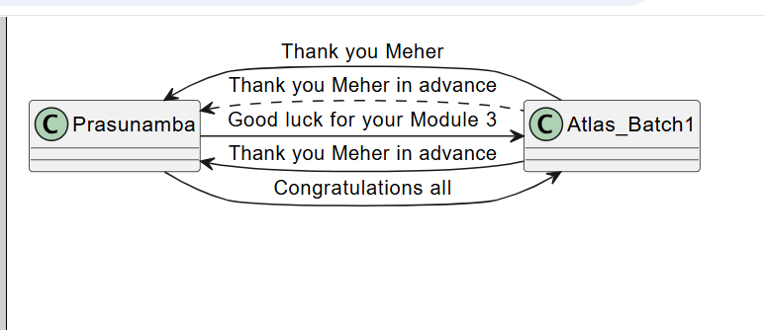

Task 5:

@startuml
pax "A" as A
pax "B" as B

A --> B: Message/action
A ..> B: reply
@enduml

A->B: HOPE READING WELL
B..>A:YES PREPARING
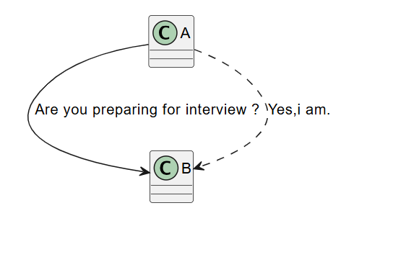

Class Daigram:
@startuml

class Car
Driver - Car : drives >
Car *- Wheels : have 4 >
Car -- Person : < owns

@enduml
